**Identifying Usability Issues**

*BottomLineTelecommunications*

**INF 132 Project Assignment #3**

Monday 6:00 P.M Discussion - Group 7:

Alonso De La Torre Vega

Matthew Morales

Phillip Nguyen

Jason Hing Lun Tam

Juwan Michael De Jesus

**Table of Contents**

**Executive Summary** **3**

**Introduction** **5**

**Description of User Population** **6**

Target Population 6

High Level Summary 6

Surveyed Population*1 6

Participant Sample*2 7

**Description of Methods** **8**

Methodology and Goals 8

Participant Recruitment 8

More Usability Test Information 8

Data Analytics  9

Usability Test 9

Cognitive Walkthrough 10

**Findings** **11**

**Appendices** **15**

Additional Usability Issue 15

Data Collection Log 16

Usability Tasks 17

Scenario #1 17

Scenario #2 18

Scenario #3 20

Scenario #4 21

Scenario #5 22

Cognitive Walkthrough Tasks 23

Scenario #1 23

Scenario #2 25

Scenario #3 27

Subsequent Usability Test Questionnaire Template 29

Participant 1 Questionnaire: 31

Participant 2 Questionnaire: 34

Participant 3 Questionnaire: 36

Participant 4 Questionnaire: 38

Participant 5 Questionnaire: 40

# **Executive Summary** Overview and Methods

BottomLineTelecommunications (shopBLT.com) is an e-commerce website that specializes in selling electronic products. The website is far from perfect and as a result, we have performed several usability tasks and scenarios in order to pinpoint these imperfections and shortcomings. The three main goals to be achieved through these tests were:

* **Product Search:** Identify key issues in product search via item querying and categorization
* **Product Details:** Understand any particular pain points users have when identifying the details of a certain product
* **Checkout and Customer Service:** Find issues users have during the product checkout process and when seeking help from customer service

To gather our qualitative data we recruited a set of our peers and some close friends that shared some of the key characteristics of our target population. Our entire sample population did not match the level of technical expertise as the core user-base of shopBLT, a few of our participant had a good grasp on technical the terminology. We also tried to recruit individuals who were online shoppers.

We identified usability issues through **usability experiments** and **cognitive walkthroughs**. The first method we conducted was our **usability experiments**. The five tasks that were given all relate to one of the aforementioned goals (see Appendix p.16 for more info). The second method we used was our **cognitive walkthroughs**. The walkthroughs helped in the identification issue process by allowing us to see from a user’s perspective and any of the possible paths they might take when trying to complete these tasks. We used an affinity diagram, and separated the qualitative data and identified more pertinent issues using a prioritization matrix.

## Findings

With our goals in mind and our methods at ploy, we carried out our tests on five different users and we discovered that the two sections that needed the most work were **product discovery** and **product identification**. When it came to **product discovery**, we found that users had to type in very specific search queries to find products or have an extensive shopping/tech background to know what products are under what categories. When it came to **product identification**, major details about the product such as price, appearance, specifications, and customer reviews were omitted, thus making it difficult for the customer to inquire more information about the product at a first-glance. Lastly, the checkout process could also use a redesign due to most of its functionalities being redundant or outdated.

# **Introduction**

Started in 1991 as a systems design and consulting firm, BottomLineTelecommunications (BLT) has since become an e-commerce website providing its customers with over 300,000 products and solutions from major manufacturers all over the world. This service is similar to those of Amazon and eBay in which customers purchase products online and have those products shipped directly to them without seeing the product in-person.

Our team’s initial impression, after initial navigation to the website, is that simple tasks like finding a certain category or product are rather difficult with the tools provided. The site fosters a haven for users with high domain knowledge of computers and electronics, yet it fails to cater to the less informed who could be potential future users of the service. Even though BLT has been in business for almost 30 years, its website (shopBLT.com) has much room for improvement.

The purpose of this section is to analyze user-performed tasks supported by the website to understand what exactly users could struggle with. Our team created several tasks and conducted a usability test and a cognitive walkthrough. Currently, there are a few areas of interest that we wish to explore further (these areas include but are not limited to):

* the terminology of product groupings
* product visibility
* product information accessibility
* navigational tools

By understanding user intentions and website shortcomings, we can offer changes that would improve the website’s usability and hopefully bring it more business.

# 

# **Description of User Population**

## Target Population

The primary user base of shopBLT includes a set of individuals, mostly male, ranging from the ages of 22 - 50, who are placed in the socioeconomic class of middle to upper-middle class. The main recurring user base is located in the United States, and thusly most of the traffic, service, and shipping are established domestically. The international population is still an important consideration, as usability between cultures is something we would like to explore to ensure the product-service employs universal usability practices. Data regarding international users however is less than abundant, and therefore, we intend to focus our efforts primarily on the domestic users. Given that a high percentage of our target population possesses high domain knowledge and expertise, we expect and *assume* that the user population frequently shops online. Other characteristics of our user population include valuing: responsiveness (both systematically and from the company), quality customer service, company transparency, secure payment methods, and brand credibility.

## High Level Summary

* Mostly male
* Ages 22 - 50
* Domestically located (high traffic in the United States)
* Users value (Non-technical)
  + Company transparency and responsiveness
  + Quality customer service
  + Secure methods of payment
  + Manufacturer credibility
* Users value (Technical)
  + System responsiveness
  + Technical jargon

## Surveyed Population*1

Of those that we surveyed and interviewed to gain a perspective on our higher level evaluative goals, we discovered that the data reflected some core characteristics of our true target population. For example, the gender distribution was fairly consistent with our target population, with the majority being male at (55%). Furthermore, most of our participants fell within the target population age range, with a few survey participants inconsistent with the range. The lowest recorded age was 18, with the mean being 26, and highest age 42. Based on participant responses, consistently held values between target population and observed population include: quality customer service, secure methods of payment, manufacturer (and retailer) credibility. The majority of our observed population did not reflect the same level of technical experience with our target population. Lastly, while all of the participants were interviewed or surveyed in the United States we have no data of ethnicity or international status, and thus cannot make any claims or connections to the target population in that respect.

## Participant Sample*2

Our participant sample for the usability tests primarily consisted of male subjects. As a whole the technical expertise of our participant sample is less than that of the target population, however; we tried to recruit participants that shared some core characteristics of our true target population. For example participant three possesses an “Advanced” level of expertise and domain knowledge similar to our target population. Our participant sample also consisted of set of individuals that share similar online shopping habits in terms of frequency. A summary of our participant population is provided in the tables below.

*1Note: We attempted to reduce bias as much as we could when gaining information from our interviewees and survey participants.

*2Note: It should be noted that our participant sample is relatively small with a size of five separate individuals. These participants are not completely representative of our target population, as the technical experience of some of our participants is less than that of the average consumer of shopBLT.

# **Description of Methods**

## Methodology and Goals

To evaluate and analyze usability issues that fall in line with our areas of interest we conducted two separate usability activities: a usability test and a cognitive walkthrough. We began by assessing the data we received and analyzed from our interviews and surveys. Subsequently, we identified common areas pertaining to crucial usability issues. From our **findings** we **identified**: ***product visibility*, *functional tool discovery*, *product information availability*,** and ***characteristics of the navigational tools*** to be **primary areas of interest**. Thusly, we designed usability test tasks around these findings to gain finer-grained specifics about usability issues in these areas.

## Participant Recruitment

Admittedly, our observed population (subjects who participated in usability tests) is not representative of our target population. We gathered our participants primarily through convenient means such as recruitment of friends, peers, etc. However, our goal was to test and analyze those who met a number of qualifying characteristics to get them as close to the target population as we could. We performed usability tests on five separate individuals in teams of two (one scribe, one facilitator).

## More Usability Test Information

For more information regarding: usability test duration, time, location, and facilitator and scribe information; please refer to the “**Data Collection Log**” table in the appendices section.

## Data Analytics

Once we gathered our data from the usability test and cognitive walkthrough, we constructed two separate affinity diagrams. A single diagram was used to interpret data from the usability tests, and the other for the cognitive walkthrough. We then discussed the issues and consolidated the overlapping pain points and while filtering out some of the other smaller more user specific difficulties that were not supported by our previous findings. Given there were numerous issues discovered, we then performed analysis of the data using a prioritization matrix, rating pain points on the dimensions of “user value gained” and “feature complexity”. Our findings and prioritized set of issues to develop solutions for include:

Product discovery:

1. Search Bar: Unoptimized boolean search algorithm that reads for keywords and produces false negatives. Presents misleading information to the user.
2. Categories: Caters to users who possess high levels of domain knowledge. Category listings use technical jargon relating to more specific areas of electronic and computer components that confuse more general users.

Product identification:

1. Product visibility: There is a feature already in place allowing for product visualization; however the feature is not available for most products and the execution of the current feature is lacking. A large image is produced that populated most of the user’s screen eliminating the ability to view other product details and other product listings.
2. Product data visualization: Product listings are displayed as tables with several columns for distinguishing information. Product information reads as technical detailing information which excludes a wide set of individuals from shopBLT’s user base.

## Usability Test

Tasks:

* Load the product page for any monitor without using the search bar.
* Reach the user information page with all fields complete and a monitor in the shopping cart.
* Get customer service help for information on exchanging a product.
* Find the dimensions of an “GRAPHICS CARD AREZ RADEON PHOENIX SERIES RX550 2GB” (using any method to navigate to the product page).
* Find a black mouse pad, with a gel wrist rest, of any size that is priced between 25$ - 35$ using the advanced search functions.

## Cognitive Walkthrough

Tasks:

* Find a black mouse pad, with a gel wrist rest, of any size that is priced between 25$ - 35$ using the advanced search functions.
* Submit a request to obtain and RMA numberto returna product to BLT.
* Find and place an order for a "Logitech Wireless Headset H800" using the category sequence.

|  |  |  |  |
| --- | --- | --- | --- |
| Participant number | Participant Description and Demographics | Level of Technical Expertise | Online Shopping Frequency |
| 1 | Gender: Female  Age: 22  Education: 3+ years in college | Intermediate level of technical domain knowledge | Occasional online shopper (NewEgg, eBay, Amazon). |
| 2 | Gender: Female  Age: 18  Education: <1 year in college | Beginner level of technical domain knowledge | Frequent online shopper (Amazon) |
| 3 | Gender: Male  Age: 21  Education: 3+ years in college | Advanced level of technical domain knowledge | Non-frequent shopper, but has knowledge on shopping |
| 4 | Gender: Male  Age: 19  Education: 2+ years in college | Intermediate level of technical domain knowledge | Occasional online shopper |
| 5 | Gender: Male  Age: 28  Education: 3+ years in college | Intermediate level of technical expertise | Shops online pretty frequently (Amazon) |

# 

# 

# 

# 

# 

# **Findings**

After conducting and analyzing the usability tests and cognitive walkthrough, there has been a decision to focus on two main issues that need a redesign to improve the performance of the BottomLineTelecommunications website. One of the main issues we found was that product discovery could be difficult to both novice and expert users of e-commerce websites. Two of the main ways users typically search for products is through a search bar or through categories that the site creates. These two functions do perform their job as intended at the lowest level, however if there is a lack of knowledge in how these functions work then it will be difficult to discover any product, even if it does exist on the website. The second main issue was that product identification could be a challenge again for both novice and expert users of online shopping. Users consider the product price, pictures, customer reviews, shipping time, shipping cost, specification, and name of the product to be essential items for available products to portray; however, on BLT’s website most of this information requires extra steps to find even though it is what customers value the most, according to our findings. Although it’s not as high a priority as the other two issues mentioned, one more section of the website that could also benefit from a redesign would be the checkout process. There’s more detail about it in the appendix, but it’s still worthy to note that the checkout process has a fair amount of redundancy and has some confusing processes that can be improved; the website still does function well and will complete the order once the inconvenient process is made.

As mentioned above, one of the main issues we found with the website was the difficulty people had in finding a desired product. In general, people understand how to use a search bar when they need to find a product on a website; on shopBLT’s website, however, using the search bar was an unanticipated issue that our users ran into. For one, when our test-subjects were searching for a product they had to assure themselves that what they inputted in the search bar was correct; “correct” in this sense meant that they couldn’t accidentally misspell the product name, nor could they make it plural, because the website wouldn’t return any results.

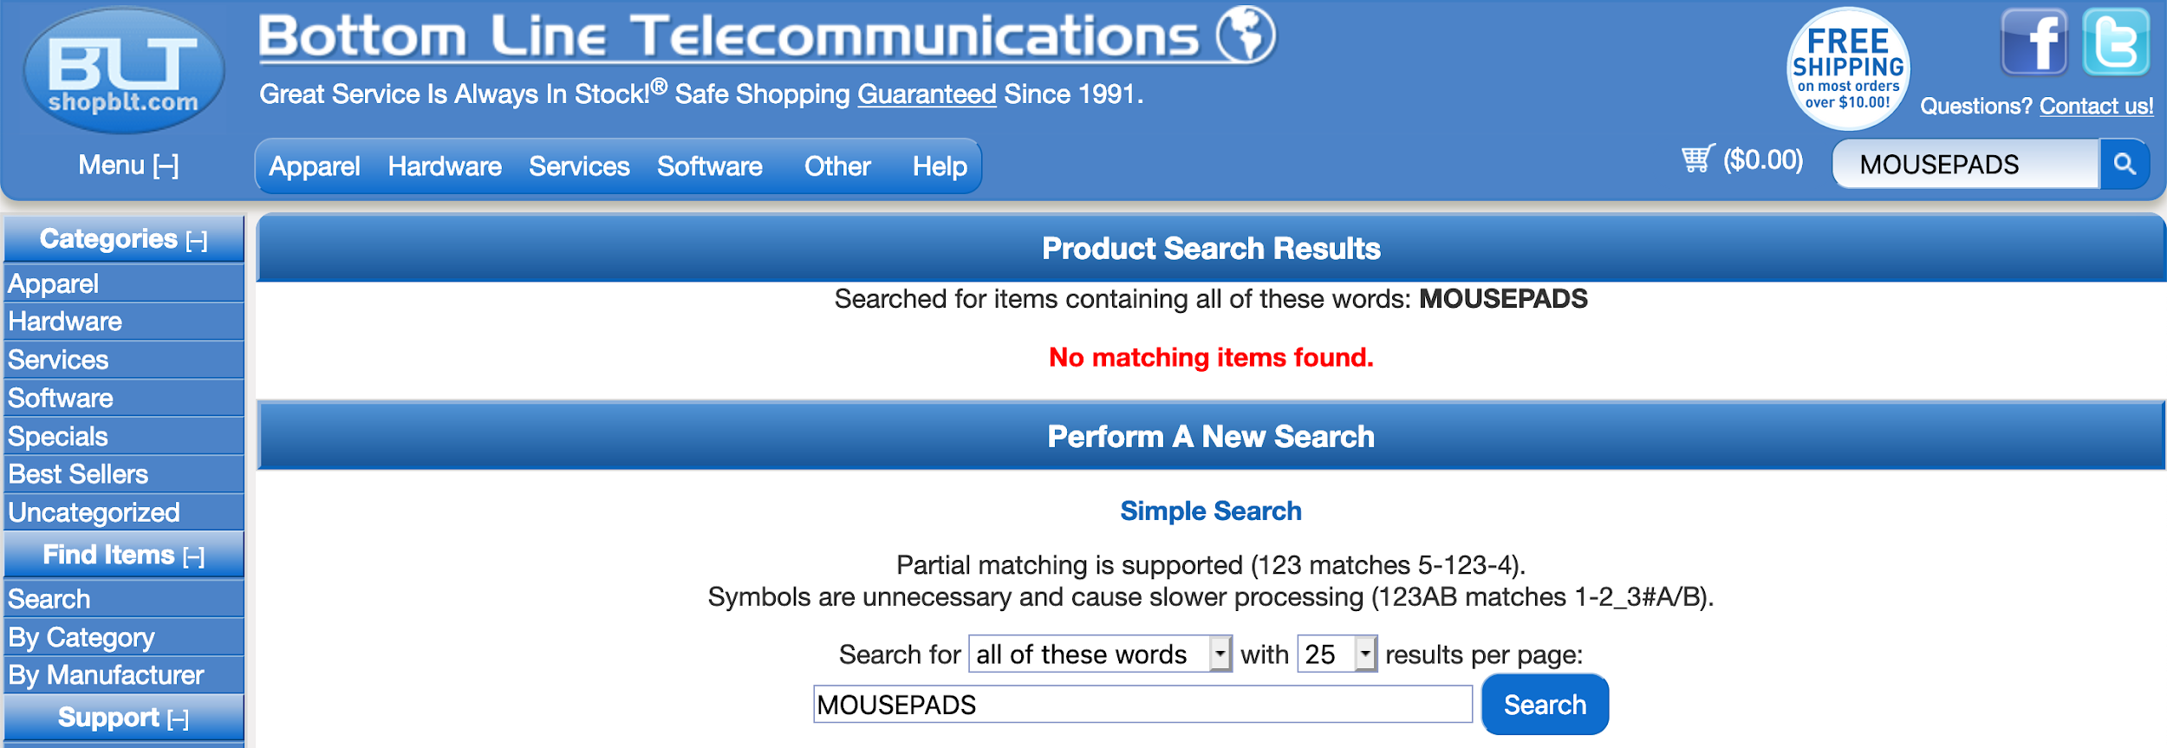

**Figure A: The results from the user typing “mousepads” in the search bar.**

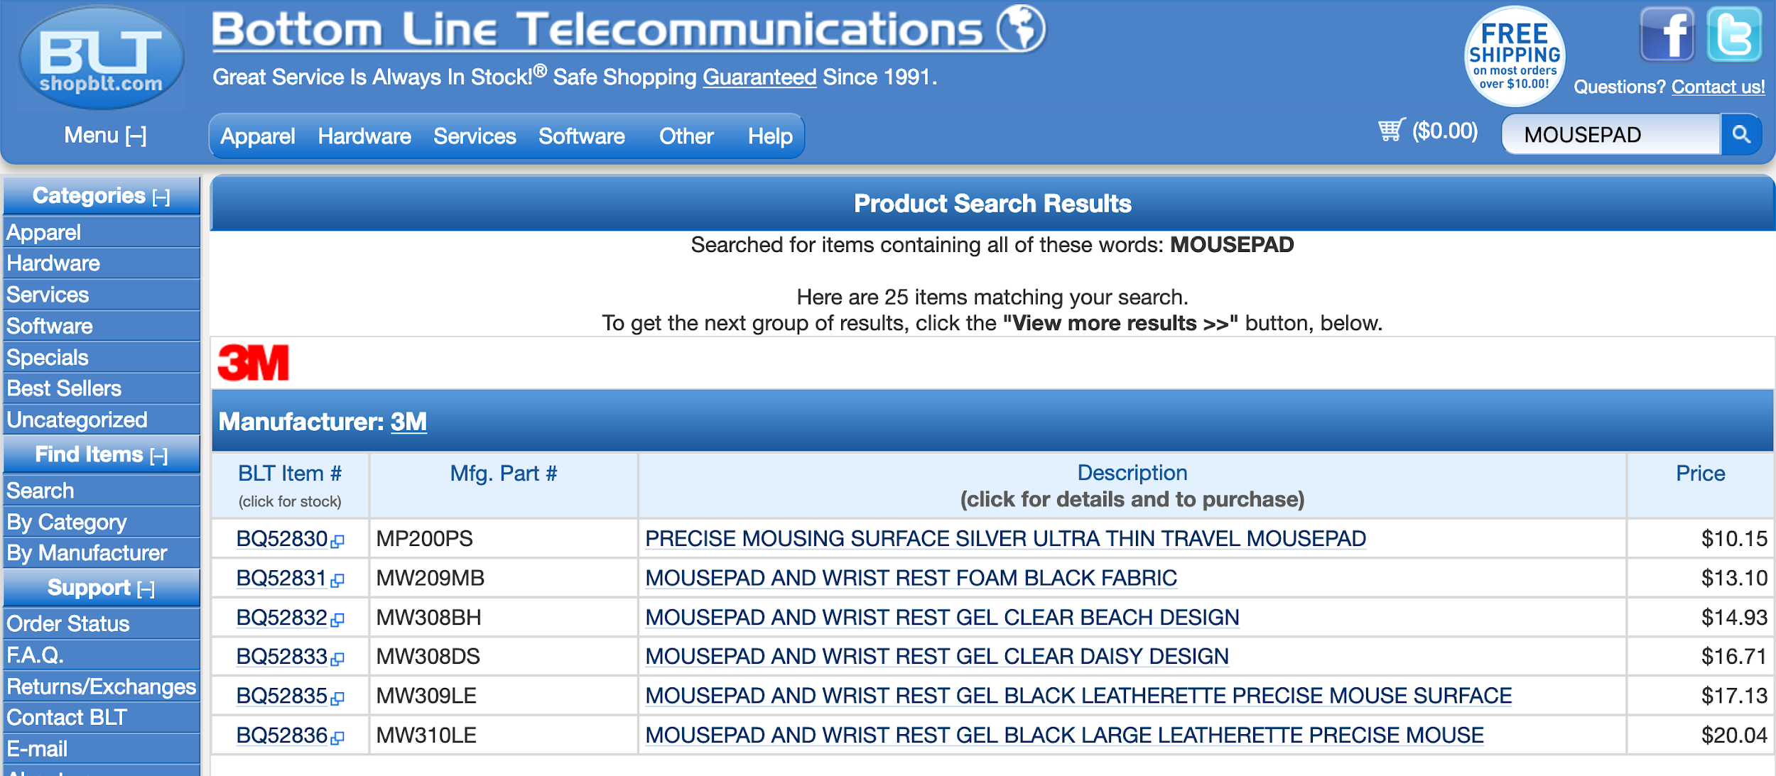

**Figure B: The results from the user typing “mousepad” in the search bar.**

Figures A and B are an example of this discrepancy, where the objective of the user was to search for a “black mousepad with a wrist rest.” Figure A demonstrates what happened when our test-subject inputted “mousepads” in the search bar, thinking that a long list of different mouse-pads would appear. Instead the website responded with zero results and our test-subject had to rethink their method of searching for the product. Figure B is the result of our test-subject changing their input, by simply removing the “s” at the end of the word and getting a full set of results. This flaw that the website has confuses the user and leads them to believe that either the website is mistakened, or it really doesn’t have the product they’re looking for. Either case, the user can’t surely know until they’ve tried every possibility and have used up all their known resources.

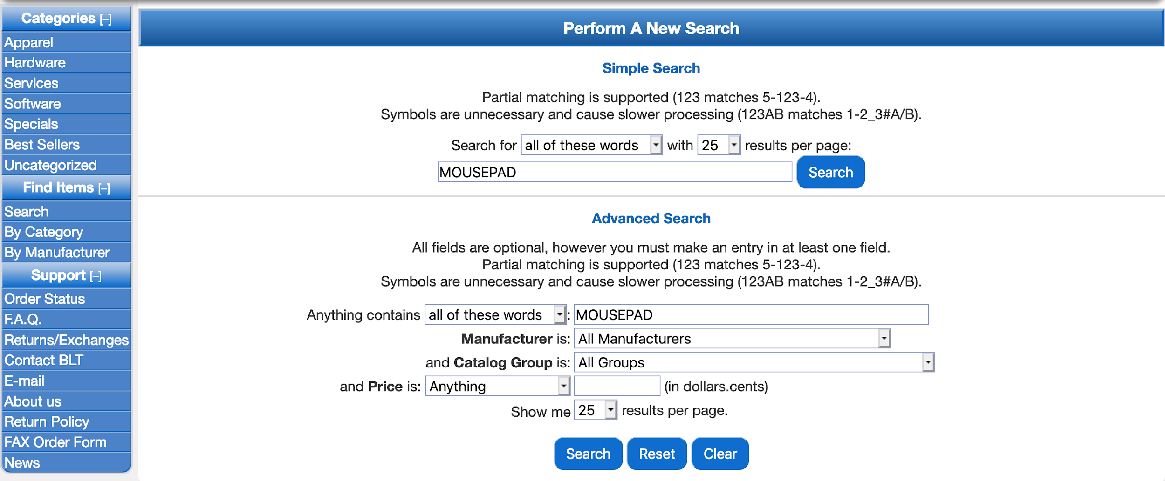

**Figure C: The filtering menu for shopBLT’s website, it’s meant to reduce product search results.**

Aside from the user just inputting text in the search bar, they also have the option of using filters to condense their search results. However, this option is not available for the user until they have already made a search query. On top of that, the filtering menu is not readily available to the user, they have to scroll all the way down past the product listings to get to the filtering menu at the bottom of the page. Figure C is an image of what the user sees when they get to the filtering menu. The features of the menu are not so great either, they provide unorthodox/non-standard metrics for filters; for example, the three grouping options provided for pricing are “Anything”, “Equal or Less Than”, and “Equal or More Than.” In general, these metrics are not what people usually consider when looking for a product; they usually consider things like “Under $10” or “$50 & Above”, or a range like “$20-$30”.

Another way users look for products on a website is through categories. Again, generally people know how to maneuver their way around a website with the categories provided; with shopBLT’s website, however, the categories are confusing and dense if a person doesn’t have prior knowledge about the site. The categories are full of jargon that only a tech savvy person will understand. “Yes they are learnable, but a person doesn’t want to spend the time to learn the categories,” as one of our test subjects said. Figure D shows one of the categories in shopBLT’s website, and how within itself has many other categories as well. The categories have jargon, such as “Graphics & Multimedia” or “Network Protocols, Drivers”, that a user must understand what the terminology means in order to proceed. Most of our test-subjects, at least 3 out of the 5, didn’t know what the terminology meant so they searched through every category of the website until they found what they were looking for. In their case, they had to learn how to maneuver themselves around the website in order to find the product.

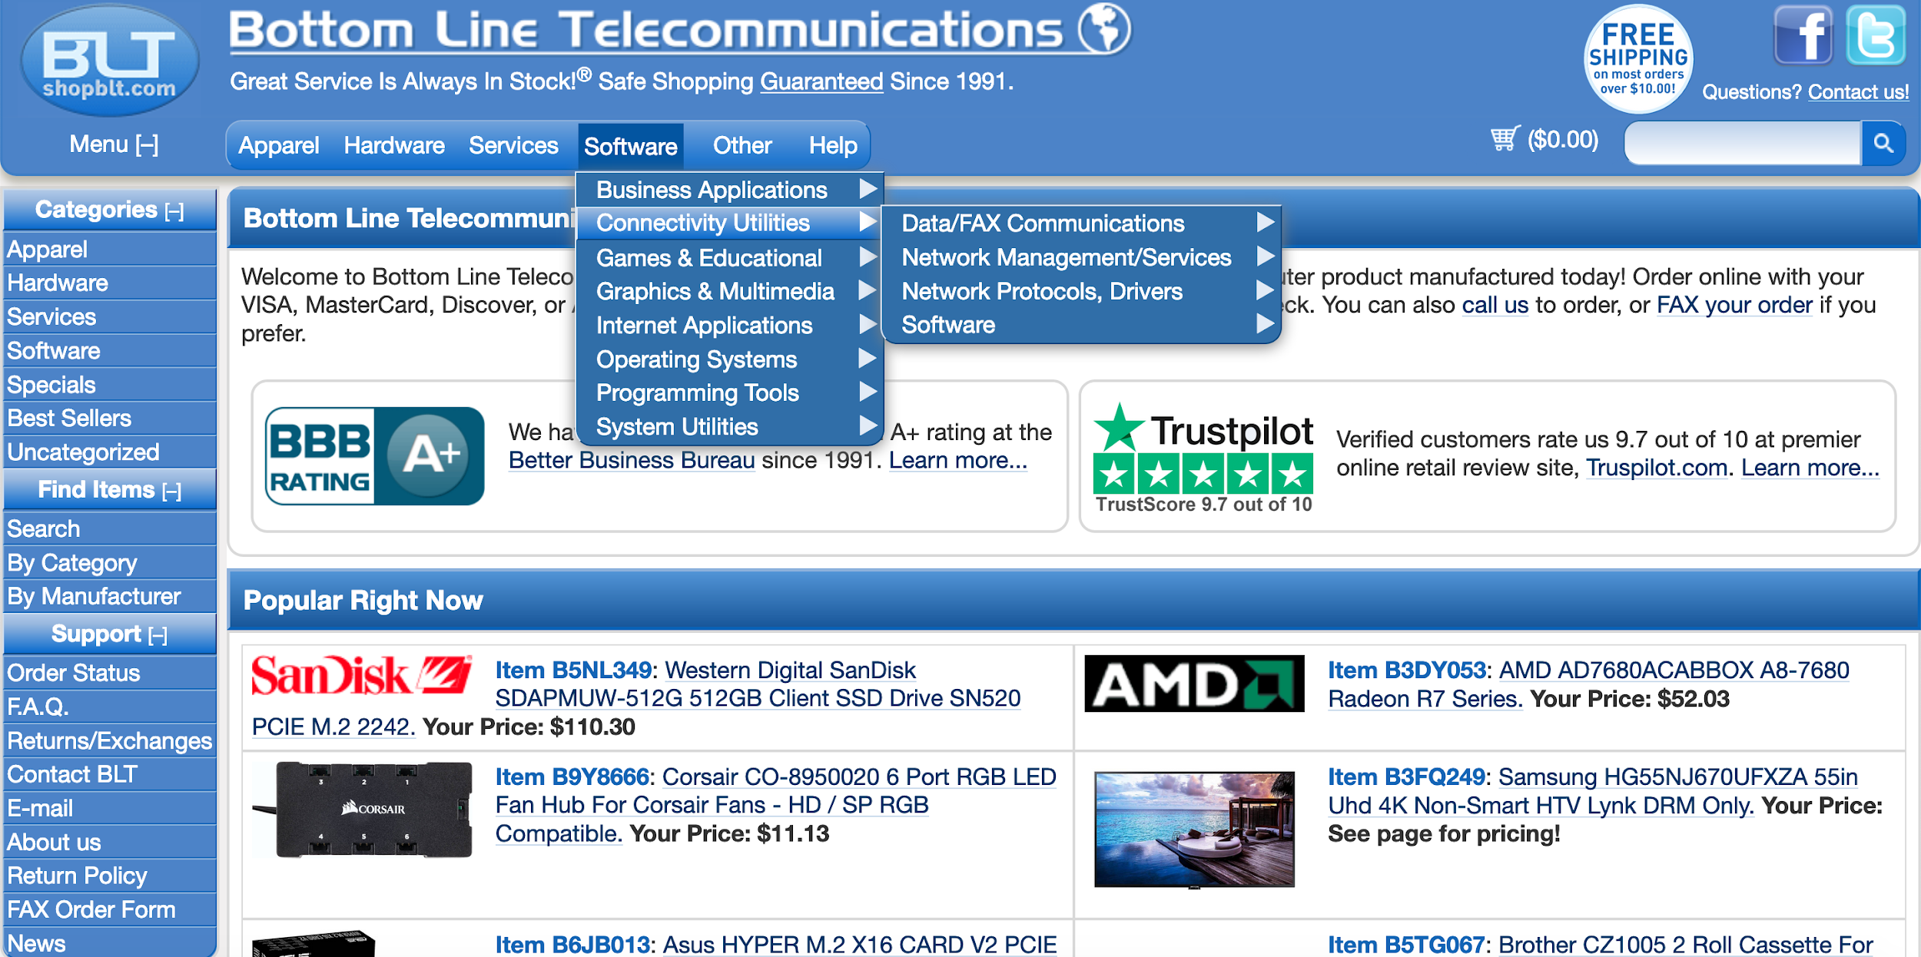

**Figure D: The drop-down menus when a user clicks on “Software,” then “Connectivity Utilities.”**

The second main issue we found on the website has to do with product identification; by this we mean that when users are looking for products, there are certain aspects about that item they want to see in order to verify that that’s what they’re looking for. These aspects include: product name, price, pictures, customer reviews, shipping time, shipping cost, and specifications.

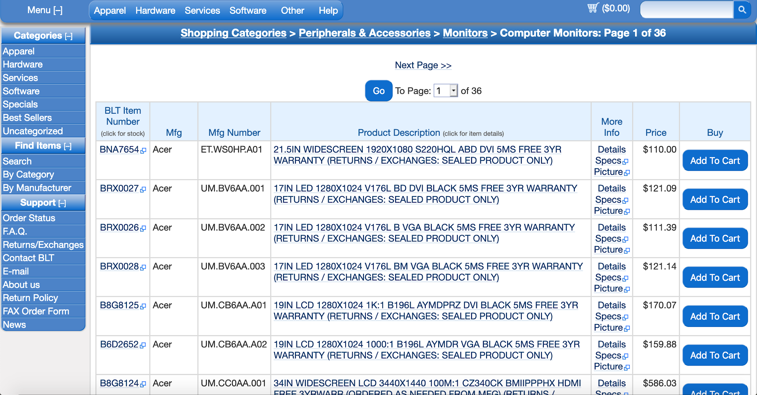

**Figure E: The results when a user clicks “Computer Monitors” in the “Hardware” category.**

Referring to Figure E, it’s clear that it’s difficult to read exactly what each product is. The easiest part to read is the price but there is no immediate image that a user can correlate the price with. The important aspects that a user wants are not readily available, which is a huge issue for shopBLT; if they want to be more appealing to their audience, shopBLT needs to consider redesigning this aspect of their website. Aside from this there also doesn’t seem to be any real order to the items listed, and as one of the test-subjects mentioned, the order seems random and it’s hard to see anything that they would want. During the cognitive walkthroughs it was determined that the site functions as intended, however the main issue lies in the fact that it’s not user friendly at all. Particularly, only users who are experienced with this site will be able to navigate it efficiently while more novice users will be rather frustrated than pleased with what the site has to offer. The intuitive parts of the website, such as adding to the cart, is there but actually locating and identifying products, which is arguably one of the most important features, is not very intuitive and will take a good amount of experience in the site to execute correctly.

In conclusion, if the two main issues we found, product discovery and product identification, are to be considered for a redesign, in return the redesign will help fix the issues on shopBLT’s website and promote higher praise from novice/expert users. As it stands now the website is in ‘good’ standing conditions from having its regularly-visiting customers, but its reputation can be immensely improved if changes are incorporated and newly-visiting customers are pleased with its functionalities.

# 

# **Appendices**

## Additional Usability Issue

One other usability issue that was determined, but not one of the main focuses for redesign, was the issue with the checkout form. The first issue that arises with the checkout form is the fact that there are two different checkout options, as shown in Figure F. It may seem desirable to choose the “Secure Check Out” option, but in reality it does not matter which one of the two is picked. This can be confusing for the user and is only one of the issues that exists in this process.

**Figure F: The checkout form when displaying the “Secure Check Out” and “Check Out” buttons.**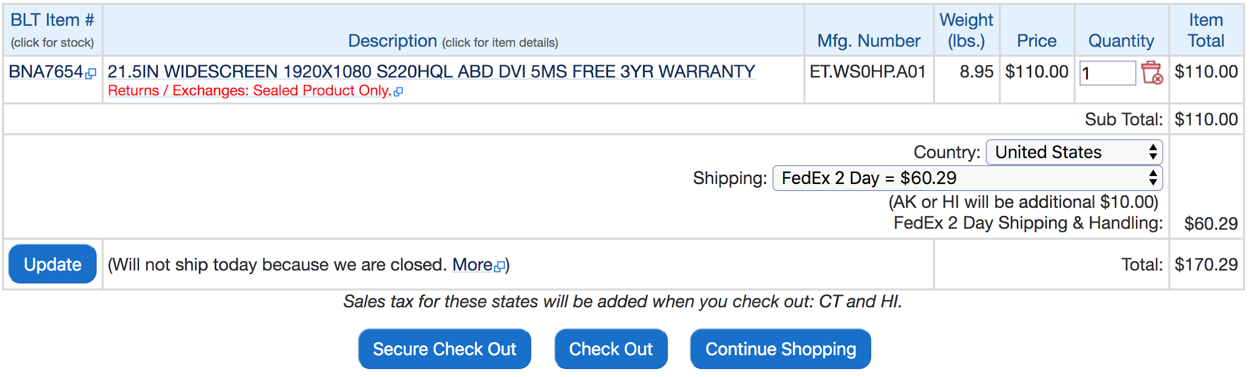

After clicking one of the checkout options, the user then has to click another button on a different page just to fill out their payment info and shipping address. The amount of time the user loses here is seemingly small, but even the smallest things are enough to irritate a user. On top of this, on the final payment form the user is required to fill in their phone number several times and provide more information than they may desire. One of the test-subjects even commented on how it was annoying to have to copy/paste some information several times and if they messed up, then they had to fill in this redundant information all over again. These small issues combined are enough criteria to make the checkout process a candidate for a redesign on shopBLT’s website.

## Data Collection Log

|  |  |  |  |  |  |  |
| --- | --- | --- | --- | --- | --- | --- |
| Participant number | Participant Description | Facilitator | Scribe | Date and Time | Duration | Location |
| 1 | Female, age 22, Occasional online shopper, Above average technical domain knowledge | Matthew Morales | Alonso De La Torre Vega | 02/19/19; 8:30PM | 37 minutes | Facilitator’s Apartment |
| 2 | Female, age 18, Frequent online shopper | Juwan De Jesus | Matthew Morales | 02/20/19; 11:50AM | 26 minutes | Facilitator’s House |
| 3 | Male, 21, Above average knowledge of technology | Phillip Nguyen | Alonso De La Torre Vega | 02/20/19;  8:30PM | 24 minutes | Facilitator’s House |
| 4 | Male, age 19, Occasional online shopper | Jason Tam | Phillip Nguyen | 02/20/19;  11:00PM | 15 minutes | Facilitator’s House |
| 5 | Male, age 28, pretty frequent online shopper | Alonso De La Torre Vega | Juwan De Jesus | 02/20/19;  9:30PM | 30 minutes | Facilitator’s House |

## 

## 

## Usability Tasks

### Scenario #1

You are looking to buy a new computer monitor for your desk. Word of mouth has led you to believe that you can get the best deal on a monitor through Bottom Line Telecommunications online store. Please visit “[shopBLT.com](http://www.shopblt.com)” in the browser in front of you and load the product page for a monitor on the website. Also, you also have an irrational fear of using shopping website search bars in this scenario, so please refrain from using any of shopBLT’s search bars in your quest to find a new monitor. Please describe what you are thinking aloud as you complete the task and tell us when you have think you have finished.

|  |  |
| --- | --- |
| **Goal / Output:** | - Successfully load the product page for any monitor, without using the search bar |
| **Inputs:** | - Category sequence |
| **Assumptions:** | - Item exists online  - Item is searchable without search |
| **Steps:** | 1. Open the shopBLT website (www.shopblt.com)  2. Click “Hardware” tab  3. Click/Hover over “Peripherals & Accessories” tab  4. Click/Hover over “Monitors” tab  5. Click/Hover over “Computer Monitors” tab  6. Click any of the monitors that appear on that page tab |
| **Success criteria:** | - Able to successfully load the correct product page |
| **Notes:** |  |

### Scenario #2

You have been browsing the selection of computer monitors on shopBLT and have discovered one that you would like to purchase. Given the credit card information below, please conduct the necessary steps needed to place an order for any monitor on shopBLT. You may use any navigation method without restriction.

|  |  |
| --- | --- |
| **Goal / Output:** | - Successfully reach the user information page with all fields completed and a monitor in the shopping cart |
| **Inputs:** | - Credit card information, shipping information |
| **Assumptions:** | - Item exists online  - Item is in stock  - The customer has read the “Terms of Sale and Return Policy” document  - Payment and shipping information is correct and will go through |
| **Steps:** | 1. Find an Acer monitor  2. Click “Add to Cart”  3. Check if order was added to cart after redirect  4. Click “Check Out” or “Secure Check Out”  5. Click “Proceed to Secure Order Form”  6. In “Payment Information”, input card type, credit card number, month, year, VCode, bank, and phone number.  7. In “Billing Information”, input name, address, city, state, zip code, email address, daytime and evening phone number.  8. Select “Ground” shipping method  9. Select “Review Order”  10. Stop at “PLACE ORDER” |
| **Success criteria:** | - A monitor must be in the shopping cart, the user successfully arrives at the page prior to reviewing order, and has completely filled out all information fields. User must successfully find the “PLACE ORDER” button. |
| **Notes:** | - The user will not actually place an order for an item, will stop at the last step before placing order for the product. Proctor should halt user before order is sent.  Name: Bobby Lee Tennyson  Payment info:   * Visa * Card Number: **4111111111111111** * Expiration: 1/2020 * CVC/VCode: 100 * Chase Bank * Phone Number: 949-949-9449   Shipping Info:   * Location: 1 Stanford Court, Irvine CA 92612 * Ground Shipping Wanted   Email Address:   * [bobby@lee.com](mailto:bobby@lee.com) |

### Scenario #3

The monitor you purchased has finally shipped to your address. Hooray! Unfortunately, you discover that the product you ordered is defective! To remedy this issue you are determined to contact customer service in order to gain further information regarding how you can go about exchanging the product for a new, working product. Your task is to find a way to email a message to customer service through the shopBLT website.

|  |  |
| --- | --- |
| **Goal / Output:** | - Get customer **service help for information** on exchanging a product |
| **Inputs:** | - Menu selection |
| **Assumptions:** | - User needs information and couldn’t find that exact information needed on the website |
| **Steps:** | 1. Expand the menu sidebar  2. Under the support section select “email”  3. Scroll down to the bottom of the page  4. Stop once they have found the email form |
| **Success criteria:** | - Successfully find the email contact form |
| **Notes:** | - Notice if the user attempts to use the option “Contact BLT” they will be redirected to resulting page of the “email” option.  - Timed  - User might try to find contact info and open external email program or webpage |

### Scenario #4

You recently discovered that you have a knack for understanding the mechanics behind building a personal computer. Your friend contacts you telling you that he has found a graphics card he thinks might fit his gaming needs; however he is unsure as to whether or not it will fit his motherboard. He asks you to find the dimensions for the “AREZ RADEON PHOENIX SERIES RX550 2GB” using the website “shopBLT.com”.

|  |  |
| --- | --- |
| **Goal / Output:** | - Find the dimensions of an “GRAPHICS CARD AREZ RADEON PHOENIX SERIES RX550 2GB” (using any method) |
| **Inputs:** | - Product search/Category sequence |
| **Assumptions:** | - Item exists online  - Item has info user is looking for |
| **Steps:** | 1. Search the product (search bar or categories)  2. Click on the product  3. Click “Specifications” tab  4. Scroll down to “Dimensions”  5. Read the info |
| **Success criteria:** | - Finding the correct dimensions of 12" x 8.7" x 2.2" |
| **Notes:** | - Make sure the user understands the steps |

### Scenario #5

Your grandmother just got her first laptop computer; however, she is unable to use the trackpad on the laptop effectively due to her arthritis. She has an optical mouse but is unable to use flat mousepads for the same reason she cannot use the trackpad. She has asked you to go online to her favorite website “shopBLT” and find a black mouse pad that is priced between 25$ - 35$ has that a wrist rest so she can use her new laptop to her heart’s content!

|  |  |
| --- | --- |
| **Goal / Output:** | - Find a black mouse pad, with a gel wrist rest, of any size that is priced between 25$ - 35$ (using any method). |
| **Inputs:** | - Product search/Category sequence |
| **Assumptions:** | - Item exists online  - Item has info user is looking for  - User understands what a mousepad with a wrist rest is. |
| **Steps:** | 1. Use the search bar to input basic product details (e.g “mouse pad”) or use the categories section to  2. Scroll to the bottom of the page and use advanced search settings  3. Under the price field select “Equal or Less Than”  4. Input the query “35” into the entry field  5. Click Search  6. Select a product that meets the criteria |
| **Success criteria:** | - The user successfully arrives at a product page with a mousepad that is black and has a wrist rest. |
| **Notes:** | - Make sure the user understands the steps |

## Cognitive Walkthrough Tasks

### Scenario #1

Your grandmother just got her first laptop computer; however, she is unable to use the trackpad on the laptop effectively due to her arthritis. She has an optical mouse but is unable to use flat mousepads for the same reason she cannot use the trackpad. She has asked you to go online to her favorite website “shopBLT” and find a black mouse pad that is priced between 25$ - 35$ that has a wrist rest so she can use her new laptop to her heart’s content!

|  |  |
| --- | --- |
| **Goal / Output:** | - Find a black mouse pad, with a gel wrist rest, of any size that is priced between 25$ - 35$ (using any method). |
| **Inputs:** | - Product search/Category sequence |
| **Assumptions:** | - Item exists online  - Item has info we is looking for  - We understand what a mousepad with a wrist rest is. |
| **Steps:** | 1. Use the search bar or categories to navigate through to product listings.  2. Scroll to the bottom of the page and use advanced search settings  3. Under the price field select “Equal or Less Than”  4. Input the query “35” into the entry field  5. Click Search  6. Select a product that meets the criteria |
| **Success criteria:** | - We successfully arrives at a product page with a mousepad that is black and has a wrist rest. |
| **Notes:** | - Make sure the steps are clear |

* **Action Sequence**:
  + **Overarching goal**: Find a black mouse pad, with a gel wrist rest, of any size that is priced between 25$ - 35$ (using any method).
  + **Sub-goal:** Locate the product search bar
    - Identify the appropriate functionality that would allow one to search for the appropriate product.
  + **Sub-goal:** Apply advanced filters
    - Input the necessary criteria to condense the search results
  + **Sub-goal:** Identify product
    - Once search has been performed identify the product with the met criteria and add it to the shopping cart.
  + **Sub-goal:** Select payment preference and provide information
    - Once prompted, identify and select the preferred approach to payment. The option selected should be wire transfer, then input the remaining information required to successfully purchase the product.
  + **Sub-goal:** Successfully Complete Purchase and Confirmation
    - Identify current state of overarching goal and reflect on whether one may or may not be aware of system state in terms of completion.

### Scenario #2

You recently purchased and received a desktop computer case from shopBLT. Excited to complete your new computer tower, you open the manufacturer packaging and discover that the case suffered severe damage during the shipping process. Furious and enraged you hastily get online to go to shopBLT to fill out a request to obtain an RMA number to return the product to BLT. Your task is to find the form and fill it out with compatible information to guarantee your return.

|  |  |
| --- | --- |
| **Goal / Output:** | - Submit a **request** to **obtain an RMA number** to returna product to BLT |
| **Inputs:** | - Help Option (Taskbar Option) |
| **Assumptions:** | - Task falls within the necessary guidelines to return a product is |
| **Steps:** | 1. Select the “Help” option in the taskbar at the top of the page  2. Click on “Returns / Exchanges”  3. Read the guidelines and requirements and ensure they are in line with the task  4. Scroll down to the bottom of the page  5. Fill out the necessary information, with the information provided  6. Stop before the request has been submitted. |
| **Success criteria:** | - We successfully fill out the form with compatible information regarding product details and reason for the return that will guarantee the receival of an RMA. |
| **Notes:** | - Make sure that we understand what constitutes the conditions for a request to be accepted. |

* **Action Sequence**:
  + **Overarching goal**: Submit a **request** to **obtain an RMA number** to returna product to BLT.
  + **Sub-goal:** Locate the help button in the taskbar.
    - Identify the appropriate functionality that would allow one to seek help whenever stuck.
  + **Sub-goal:** Identify “Returns/Exchanges”.
    - Find the right functionality in order to progress to obtain the overarching goal.
  + **Sub-goal:** Confirm that the task is in line with the policies.
    - Get the right information to confirm what you need to fulfill your need to exchange or return.
  + **Sub-goal:** Fill out the necessary information, with the information provided
    - In order to get assistance, fill out information to receive help.
  + **Sub-goal:** Stop before the request has been submitted.
    - For this purpose, no need to actually submit request.

### Scenario #3

You are a part of the UCI esports team on campus. You and your team have been invited to go to a gaming convention, where you will compete against other esports teams around the area. Excited to go, you start packing all your belongings and realize that you’re missing your gaming headphones. The convention is in three days and you don’t have any headphones to take with you. Oh no! Immediately you start looking for some headsets online, knowing you don’t have time to go to any physical stores. You come across the “shopBLT” website and notice that they have high-quality, low-priced headsets with expedited shipping. Relieved that you found a solution, you start searching the website for different products. Your task is to place a FedEx 2-Day shipping order for a pair of “Logitech Wireless Headset H800” via wire transfer.

|  |  |
| --- | --- |
| **Goal / Output:** | - Find and place a FedEx 2-Day Shipping order for a "Logitech Wireless Headset H800" using the search bar. Payment information type is wire transfer. |
| **Inputs:** | - Search Bar |
| **Assumptions:** | - Item exists online  - We have the minimum viable domain knowledge about the product to accomplish the task |
| **Steps:** | 1. Use the search bar to query “Logitech Wireless Headset H800”  2. Click on the product titled "Wireless Headset 800"  3. Add the product to your cart  4. Under the field “Country” select “United States”  5. Click “Check Out” to complete purchase with BLT’s normal server (Not secure check out)  6. Click “Proceed to Secure Order Form”  7. Enter the “Payment Information”, with the information provided  8. Enter the “Billing Information”, with the information provided  9. Select “Ground” shipping method  10. Select “Review Order”  11. Stop at “PLACE ORDER” |
| **Success criteria:** | - Successfully enters the necessary information stops before placing an order for a Logitech Wireless Headset H800. There is only one product in the cart. |
| **Notes:** |  |

* **Action Sequence**:
  + **Overarching goal**: Submit a **request** to **obtain an RMA number** to returna product to BLT
  + **Sub-goal:** Locate the taskbar
    - Identify the appropriate functionality that would allow one to search for the appropriate product.
  + **Sub-goal:** Identify correct product
    - Once the search has been performed identify the correct product and add it to the cart. Reflect on whether or not the system state is clear in terms of task completion.
  + **Sub-goal:** Select Payment Preference and Shipping Method
    - Once prompted, identify and select the preferred approach to payment and shipping. The options selected should be wire transfer and FedEx 2-Day shipping.
  + **Sub-goal:** Provide Information
    - Provide all necessary information required to successfully book the preferred hotel (that adequately fulfills the disability condition requirements).
  + **Sub-goal:** Successfully Complete Purchase and Confirmation
    - Identify current state of overarching goal and reflect on whether one may or may not be aware of system state in terms of completion.

## Subsequent Usability Test Questionnaire Template

* What is your gender? _________
* What year were you born? __________
* What’s your highest education level?
  + Elementary School
  + Middle School
  + High School
  + 1-2 years of college
  + 3+ years of college
* If at all, how satisfied are you with the tools provided to accomplish the tasks we asked you to complete?
  + Not satisfied
  + Somewhat satisfied
  + Very satisfied
  + Extremely satisfied
* If at all, how satisfied are you with the interface of the system we asked you to use?
  + Not satisfied
  + Somewhat satisfied
  + Very satisfied
  + Extremely satisfied
* How likely are you to use this system for your own personal use?
  + Not likely at all
  + Somewhat likely
  + Very likely
  + Extremely likely
* After using the product what do you think of it (any comments, questions, or recommendations)? ____________________
* Is there anything that you wish I had asked you? ____________________
* Is there anything else that you would like to say (any comments, questions, or recommendations to the system or the usability test)?

### Participant 1 Questionnaire:

* What is your gender? **Female**
* What year were you born? **1997**
* What’s your highest education level?
  + Elementary School
  + Middle School
  + High School
  + 1-2 years of college
  + **3+ years of college**
* If at all, how satisfied are you with the tools provided to accomplish the tasks we asked you to complete?
  + Not satisfied
  + **Somewhat satisfied**
  + Very satisfied
  + Extremely satisfied
* If at all, how satisfied are you with the interface of the system we asked you to use?
  + **Not satisfied**
  + Somewhat satisfied
  + Very satisfied
  + Extremely satisfied
* How likely are you to use this system for your own personal use?
  + Not likely at all
  + **Somewhat likely**
  + Very likely
  + Extremely likely
* After using the product what do you think of it (any comments, questions, or recommendations)?
  + **“I feel like it’s easy to complain, but there are so many different things, so they have to be categorized a certain way. For tech website the categories are good, but it gets hard to navigate once you get to the product listings page. It’s confusing because I don’t even know how its sorted, it looks kind of random, because you have the product information but it’s the fourth column in the table and there are no pictures. The first column is BLT item number which is not how the products are sorted, they are sorted by manufacturer, alphabetically.”**
* Is there anything that you wish I had asked you?
  + **“Not really, no.”**
* Is there anything else that you would like to say (any comments, questions, or recommendations to the system or the usability test)?
  + **“Everything is fine, the only thing I found really confusing is the product listing, the navigation is fine for people who know what they are doing, the categories cater to those who are tech savvy and the search bar is a catch all for everyone else.”**
  + **“If you take the time to learn how the website it set up and where different categories will take you, then it’s easy to use. But most people don’t want to spend the time to learn, if you were tech savvy it would be easier. There is jargon on the website that only tech savvy people would understand. Like the first task you gave me, I didn’t know if the item was hardware.”**

### Participant 2 Questionnaire:

* What is your gender? **Male**
* What year were you born? **1990**
* What’s your highest education level?
  + Elementary School
  + Middle School
  + High School
  + 1-2 years of college
  + **3+ years of college**
* If at all, how satisfied are you with the tools provided to accomplish the tasks we asked you to complete?
  + Not satisfied
  + Somewhat satisfied
  + **Very satisfied**
  + Extremely satisfied
* If at all, how satisfied are you with the interface of the system we asked you to use?
  + Not satisfied
  + **Somewhat satisfied**
  + Very satisfied
  + Extremely satisfied
* How likely are you to use this system for your own personal use?
  + Not likely at all
  + Somewhat likely
  + **Very likely**
  + Extremely likely
* After using the product what do you think of it (any comments, questions, or recommendations)?
  + **“Make the website more appealing to the eye. The website doesn’t look like a shopping website, it looks more like an excel spreadsheet.”**
* Is there anything that you wish I had asked you?
  + **“Nope.”**
* Is there anything else that you would like to say (any comments, questions, or recommendations to the system or the usability test)?
  + **“No more questions, thank you.”**

### Participant 3 Questionnaire:

* What is your gender? **Male**
* What year were you born? **1997**
* What’s your highest education level?
  + Elementary School
  + Middle School
  + High School
  + **1-2 years of college**
  + 3+ years of college
* If at all, how satisfied are you with the tools provided to accomplish the tasks we asked you to complete?
  + Not satisfied
  + **Somewhat satisfied**
  + Very satisfied
  + Extremely satisfied
* If at all, how satisfied are you with the interface of the system we asked you to use?
  + **Not satisfied**
  + Somewhat satisfied
  + Very satisfied
  + Extremely satisfied
* How likely are you to use this system for your own personal use?
  + **Not likely at all**
  + Somewhat likely
  + Very likely
  + Extremely likely
* After using the product what do you think of it (any comments, questions, or recommendations)?
  + **“It was a terrible experience.”**
* Is there anything that you wish I had asked you?
  + **“No.”**
* Is there anything else that you would like to say (any comments, questions, or recommendations to the system or the usability test)?
  + **“System needs improvement, usability tests pointed out the flows of the system. The overall design needs to be user-friendly and intuitive.”**

### Participant 4 Questionnaire:

* What is your gender? **Male**
* What year were you born? **1999**
* What’s your highest education level?
  + Elementary School
  + Middle School
  + High School
  + **1-2 years of college**
  + 3+ years of college
* If at all, how satisfied are you with the tools provided to accomplish the tasks we asked you to complete?
  + Not satisfied
  + **Somewhat satisfied**
  + Very satisfied
  + Extremely satisfied
* If at all, how satisfied are you with the interface of the system we asked you to use?
  + Not satisfied
  + **Somewhat satisfied**
  + Very satisfied
  + Extremely satisfied
* How likely are you to use this system for your own personal use?
  + **Not likely at all**
  + Somewhat likely
  + Very likely
  + Extremely likely
* After using the product what do you think of it (any comments, questions, or recommendations)?
  + **“I think it was fine. Did it’s job. Not really user friendly.”**
* Is there anything that you wish I had asked you?
  + **“No.”**
* Is there anything else that you would like to say (any comments, questions, or recommendations to the system or the usability test)?
  + **“No.”**

### Participant 5 Questionnaire:

* What is your gender? **Female**
* What year were you born? **2000**
* What’s your highest education level?
  + Elementary School
  + Middle School
  + High School
  + **1-2 years of college**
  + 3+ years of college
* If at all, how satisfied are you with the tools provided to accomplish the tasks we asked you to complete?
  + Not satisfied
  + **Somewhat satisfied**
  + Very satisfied
  + Extremely satisfied
* If at all, how satisfied are you with the interface of the system we asked you to use?
  + Not satisfied
  + **Somewhat satisfied**
  + Very satisfied
  + Extremely satisfied
* How likely are you to use this system for your own personal use?
  + **Not likely at all**
  + Somewhat likely
  + Very likely
  + Extremely likely
* After using the product what do you think of it (any comments, questions, or recommendations)?
  + **“None.”**
* Is there anything that you wish I had asked you?
  + **“Nope.”**
* Is there anything else that you would like to say (any comments, questions, or recommendations to the system or the usability test)?
  + **“N/A.”**